DOCUMENTATION OF ASSIGNMENT

HERE IS COMPLETE DOCUMENTATION OF TASK MANAGEMENT APPLICATION IN DETAILS

1. First of all register user so you can get access the task and perform crud operation you can register as user as well as admin (Note:- user doesn’t have authority to delete task)

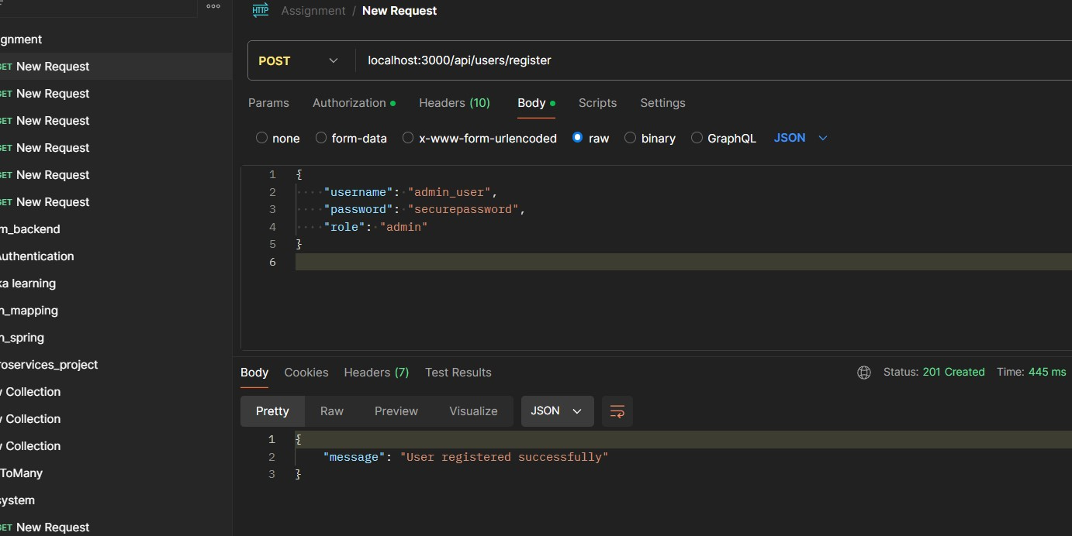

1. Now you can login using your credentials

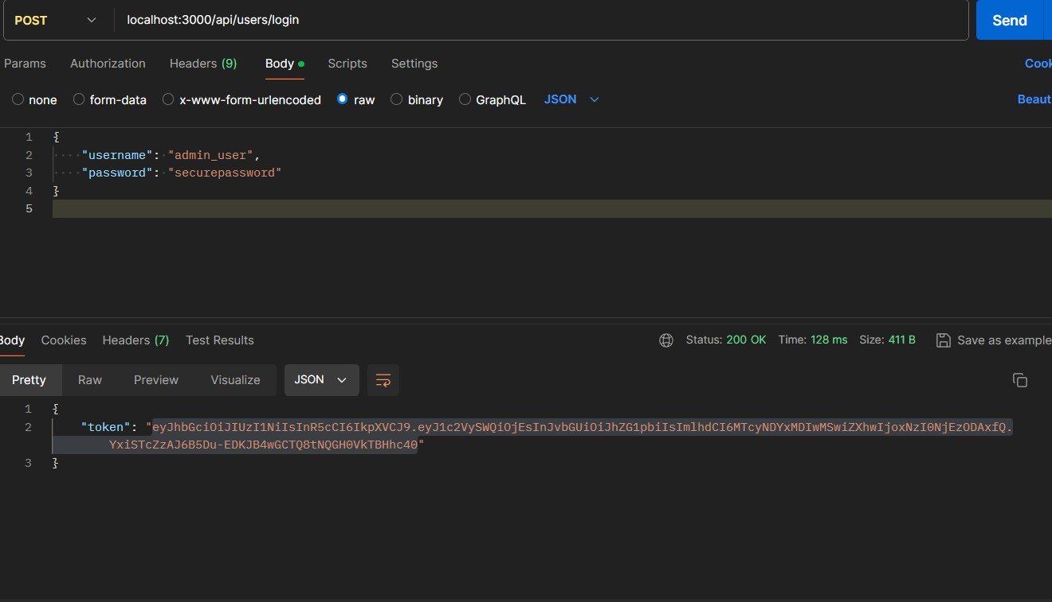

1. Now you can get bearer token, you can user this token to access crud operation API you can put token in authorization in postman as well you can put in header also with key “Authorization”

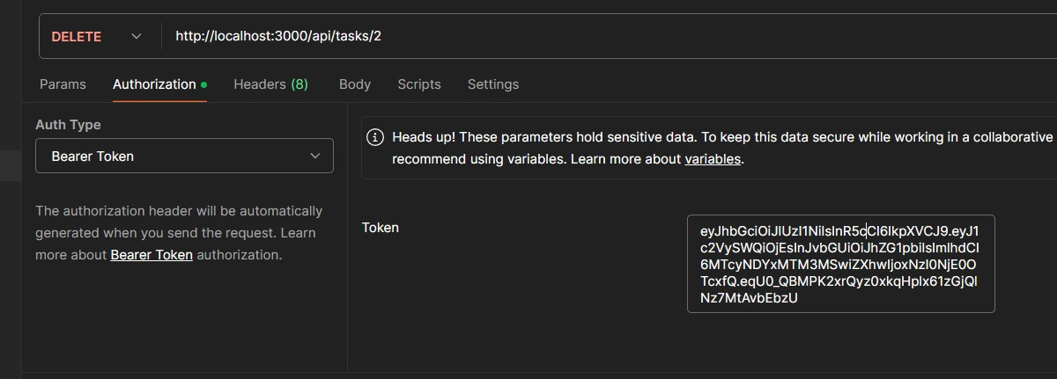

1. By using token you can perform crud operation
2. Create task

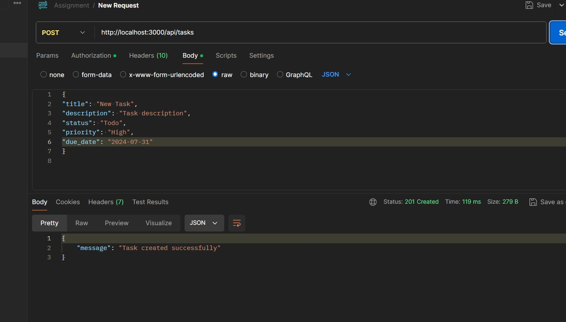

1. Get Task

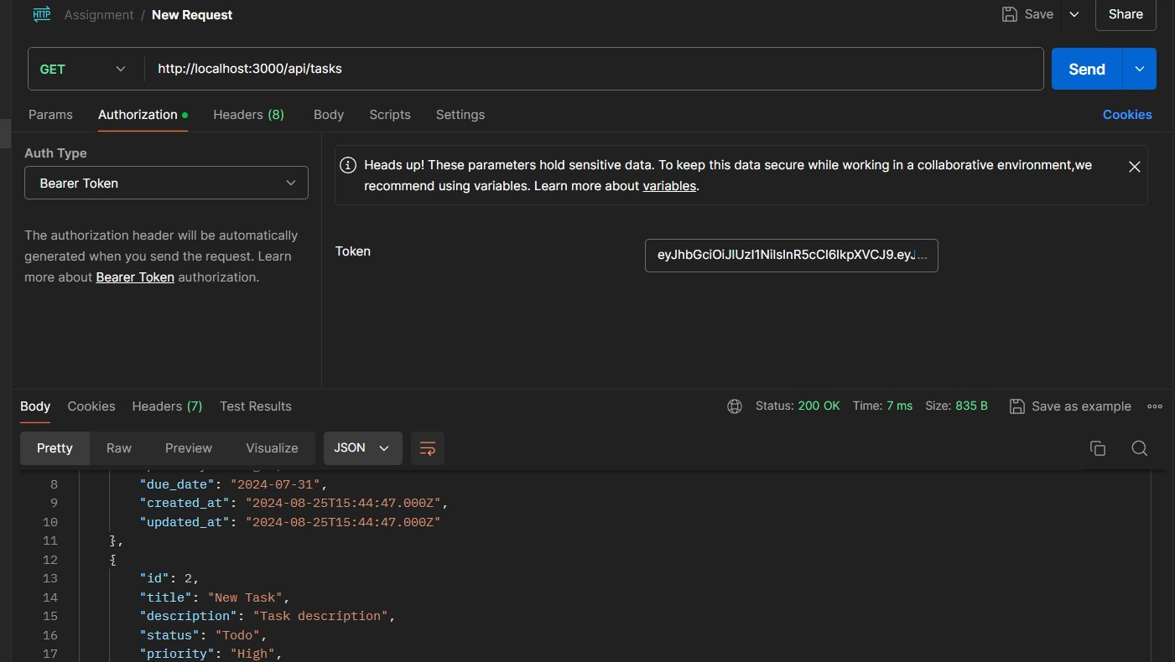

1. Update task

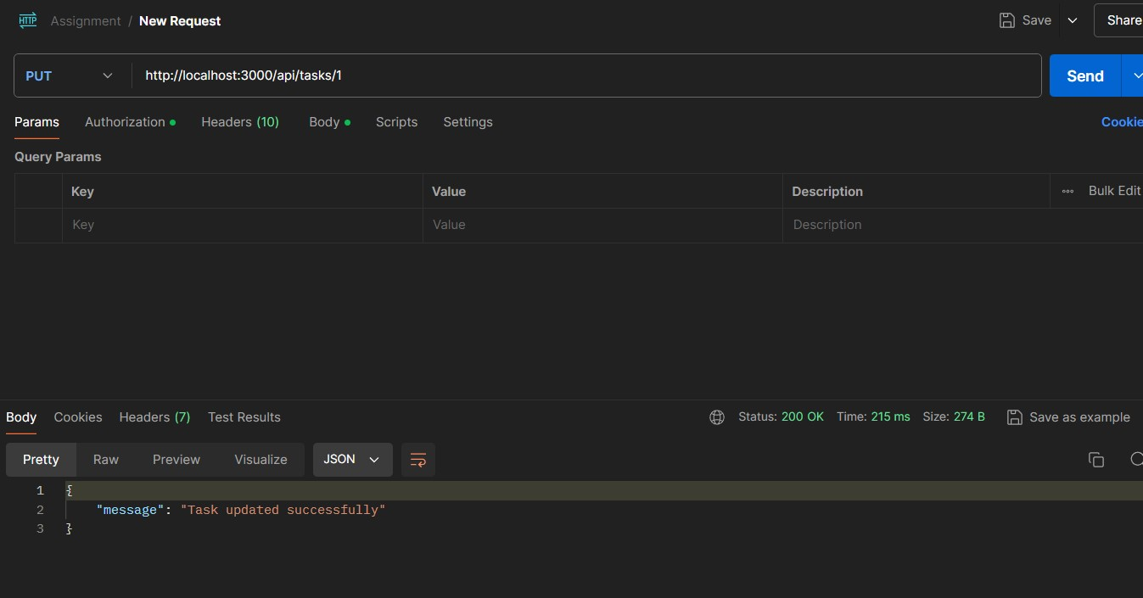

1. Delete task

